**Huaiyang cuisine**

Huaiyang cuisine (淮揚菜) is one of the Four Great Traditions in Chinese cuisine. It is derived from the native cooking styles of the region surrounding the lower reaches of the Huai and Yangtze rivers, and centred upon the cities of Huai'an, Yangzhou and Zhenjiang in Jiangsu Province. Although it is one of several sub-regional styles within Jiangsu cuisine, Huaiyang cuisine is widely seen in Chinese culinary circles[1] as the most popular and prestigious style of Jiangsu cuisine – to a point where it is considered to be among one of the Four Great Traditions (四大菜系) that dominate the culinary heritage of China, along with Cantonese cuisine, Shandong cuisine and Sichuan cuisine.

**Yangzhou fried rice**

Yangzhou fried rice or Yeung Chow fried rice (Traditional Chinese: 揚州炒飯; Simplified Chinese : 扬州炒饭;) is a popular Chinese-style wok fried rice dish in many Chinese restaurants throughout the world. It is commonly sold in the UK as special fried rice and in the US as house fried rice.

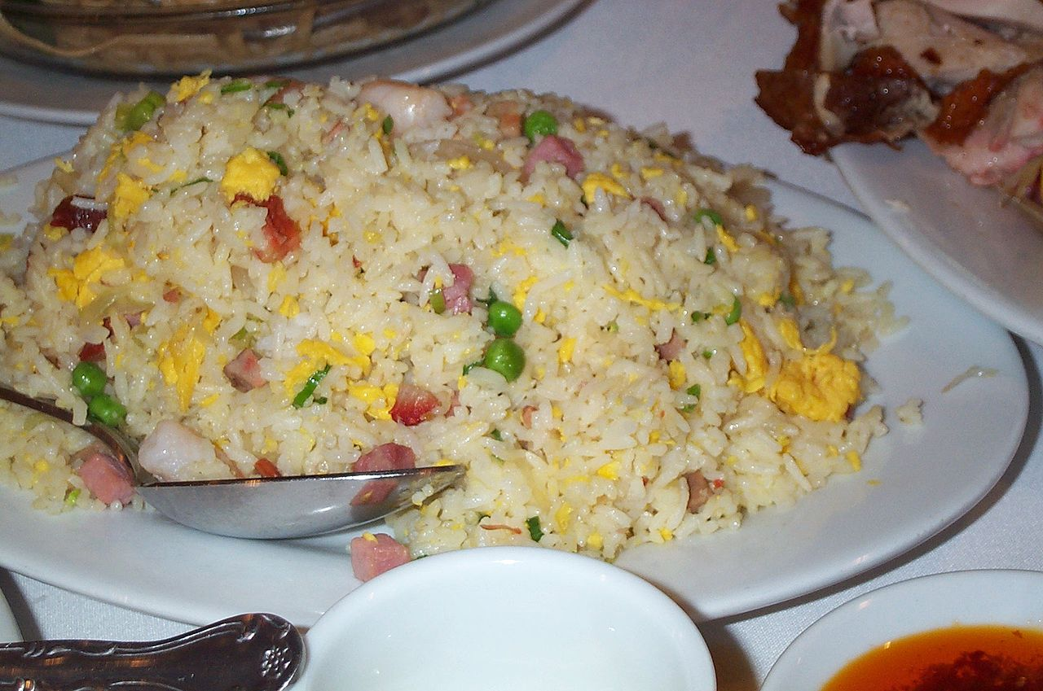

**Huangqiao Sesame Cake**

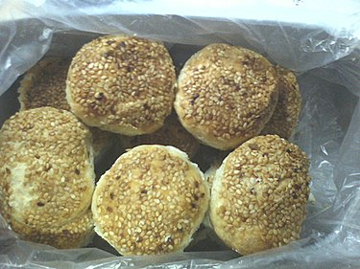

Huangqiao sesame cake (simplified Chinese: 黄桥烧饼）is a sesame seed cake that originated from Huangqiao town in Taixing, Jiangsu. It has been speculated to be one of the oldest cakes in the Taizhou region of China.